|  |  |  |  |  |
| --- | --- | --- | --- | --- |
| C:\Users\David\Dropbox\rossmoyne.png  **Reading Time**: An initial **2 minutes** to view **BOTH** sections | **MATHEMATICS METHODS : UNITS 3 & 4, 2022**  Test 2 – (10%) 3.2.4, 3.2.5, 3.2.8 to 3.2.22, 3.1.1 – 3.1.6, 3.1.9 | | |  |
| **Time Allowed**  30 minutes | | **First Name Surname** | **Marks**  29 marks | |

**Circle your Teacher’s Name:** Mrs Alvaro Mrs Bestall Mrs Fraser-Jones Mr Gibbon Mrs Greenaway Mr Koulianos Mr Luzuk Mrs Murray Mr Tanday

|  |  |
| --- | --- |
| **Assessment Conditions: *(N.B. Sufficient working out must be shown to gain full marks)***   |  | | --- | | * Calculators: Not Allowed * Formula Sheet: Provided * Notes: Not Allowed | |

**PART A – CALCULATOR FREE**

Question 1 [2, 2, 1 — 5 marks]

**Differentiate** the following. **(do not simplify your answer)**

(a) 

(b) 

(c) 

**Question 2 [2,1 - 3 marks]**

The motion of a particle, where  is the displacement of the particle in metres, and  is time in seconds, can be described by



1. Find the change in displacement during the first 3 seconds.
2. Interpret your result from (i)

**Question 3 [1 mark]**

A particle is moving along a straight line. The graph shows the acceleration of the particle.

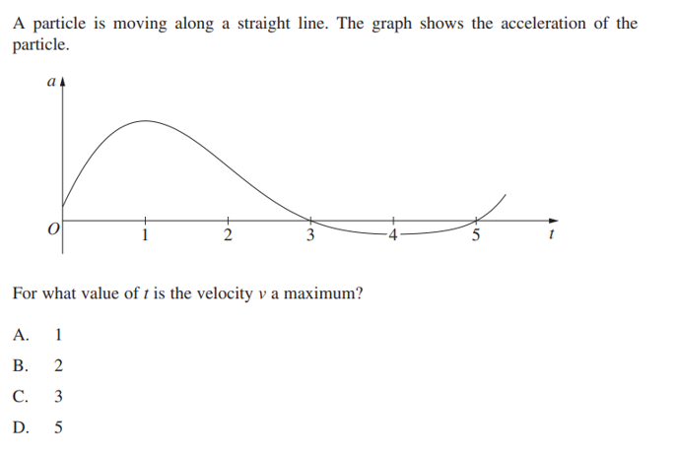

For what value of  is the velocity  a maximum ?

**Question 4 [2, 2, 2 - 6 marks]**

1. If  determine the value of 
2. If  determine the value of 

1. Find  if 

**Question 5 [1, 1, 1, 1 - 4 marks]**

The graphs of  and  are shown below.

The graphs intersect on the  at points  and form the regions that are

labelled A, B, C and D

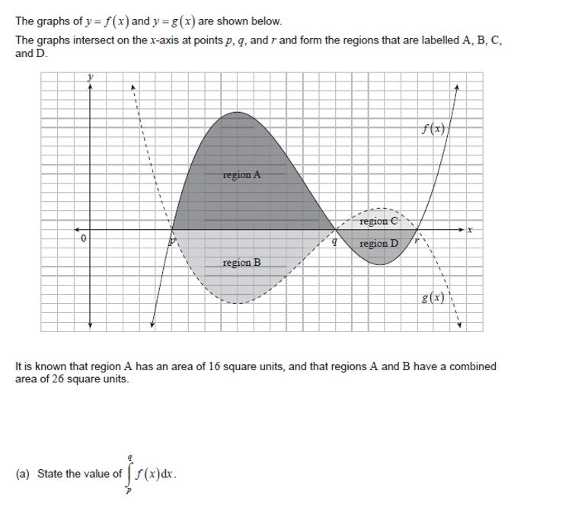

It is known that region A has an area of  square units, and that regions A and B have a

combined area of  square units.

1. State the value of 

1. State the value of 

It is also known that  and 

1. Find the area of region C
2. Calculate the value of 

Question 6 [2, 3 - 5 marks]

(a) Determine 

(b) Hence, determine 

**Question 7 [2, 3 – 5 marks]**

1. Find 
2. If  and 

find 

**End of section**

|  |  |  |  |  |
| --- | --- | --- | --- | --- |
| C:\Users\David\Dropbox\rossmoyne.png  **Reading Time**: An initial **2 minutes** to view **BOTH** sections | **MATHEMATICS METHODS : UNITS 3 & 4, 2022**  Test 2 – (10%) 3.2.4, 3.2.5, 3.2.8 to 3.2.22, 3.1.1 – 3.1.6, 3.1.9 | | |  |
| **Time Allowed**  20 minutes | | **First Name Surname** | **Marks**  23 marks | |

**Circle your Teacher’s Name:** Mrs Alvaro Mrs Bestall Mrs Fraser-Jones Mr Gibbon Mrs Greenaway Mr Koulianos Mr Luzuk Mrs Murray Mr Tanday

|  |  |
| --- | --- |
| **Assessment Conditions: *(N.B. Sufficient working out must be shown to gain full marks)***   |  | | --- | | * Calculators: Allowed * Formula Sheet: Provided * Notes: Not Allowed | |

**PART B – CALCULATOR ALLOWED**

Question 8 [3,2 — 5 marks]

The acceleration, *a*(*t*) m/s2, of a particle at time *t* seconds is given by

 where 

The velocity of the particle at *t* = 0 is 2 m/s.

(a) Find when the particle first changes direction, correct to four decimal places.

(b) Find the total distance that the particle travelled during the given time interval.

(Give your answer in metres, correct to 2 decimal places)

Question 9 [3 marks]

The region enclosed by  and  is shaded in the diagram

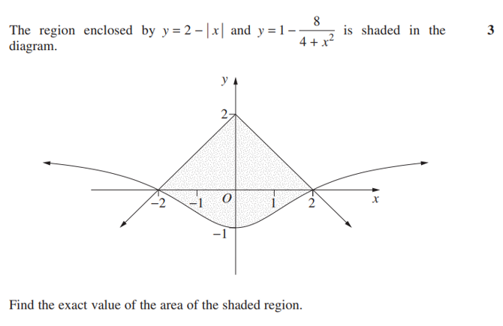

Find the **exact** value of the area of the shaded region

Question 10 [1,2,2 - 5 marks]

Marie Curie, a French – Polish physicist and chemist, was the first woman to win a Nobel Prize, the first person and only woman to win twice, and the only person to win a Nobel Prize in two different sciences. In 1909, she succeeded in isolating 1 gram of pure radium. The decay function of radium ( the amount remaining after  years) is approximately

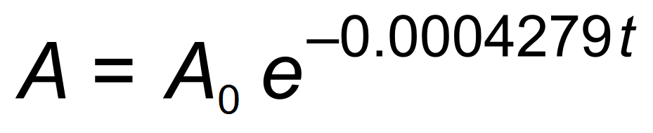 where *t* is time in years.

1. How much of the  of radium remains after 10 years.
2. Find the instantaneous decay rate after 10 years.

1. Determine the half-life of radium ?.Give your answer to the nearest year.

Question 11 [3, 1, 2 - 6 marks]

Consider the graph of  , below, where

 

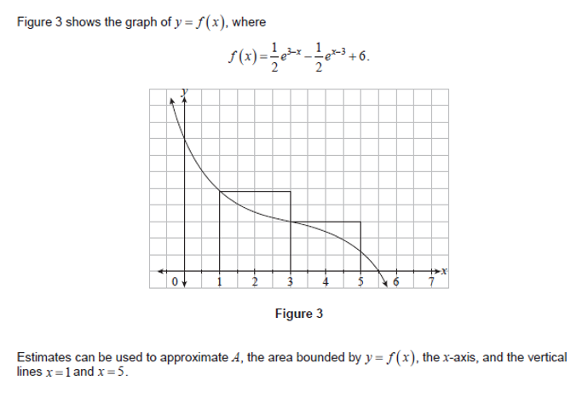

Estimates can be used to approximate A, the area bounded by  , the  , and

the vertical lines  and 

1. An upper estimate,  , of A can be calculated using the areas of two rectangles

of equal width, as shown in the diagram above.

Find the **exact** value of 

A lower estimate,  , of A can be calculated using the areas of two rectangles of equal width, S , as shown in the diagram below.

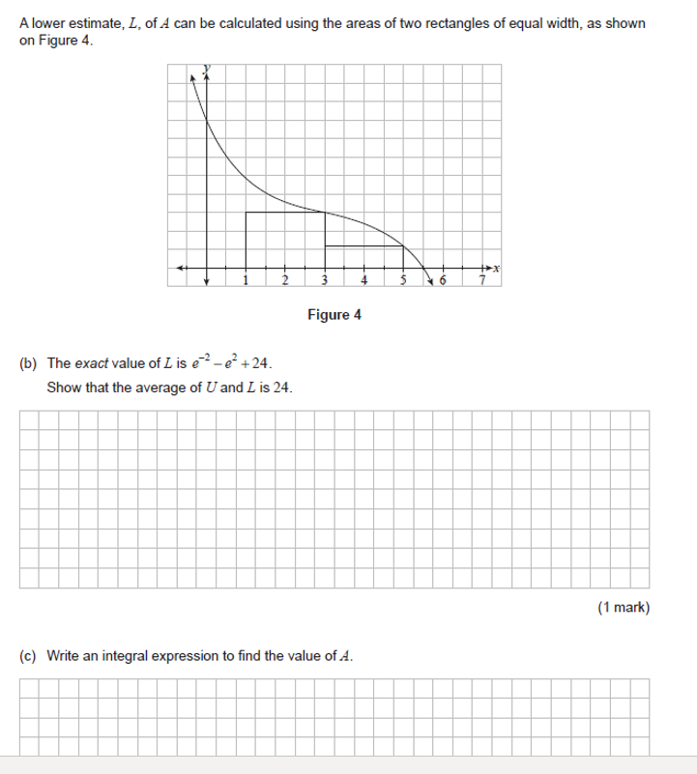

1. The **exact** value of  is given by 

Show that the average of  and  is 24

1. Calculate the **exact** value of A 

Question 12 [2, 2 - 4 marks]

The diagram shows two parabolas  and  , where 

The two parabolas intersect at the origin, and at A

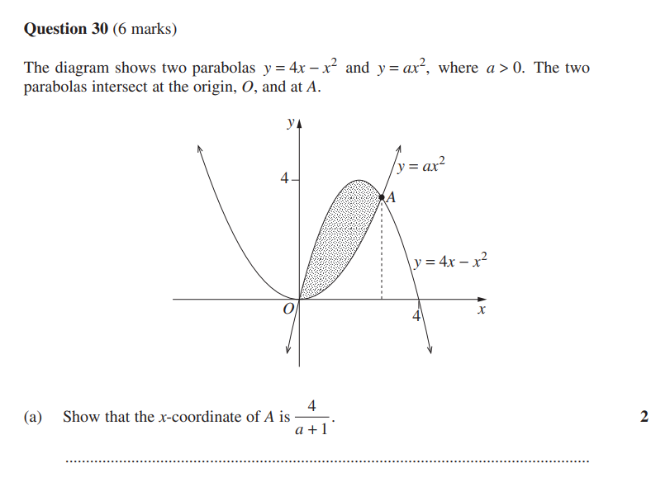

1. **Show** that the - coordinate of A is 
2. Find the **exact** value of  such that the shaded area is 

**End of section**

**Extra Page 1**